**ABDUL RASHEED**

**2012-EE-99**

Computer Networking Lab

WireSHARK: DNS v6.01

**Wireshark Lab : DNS v6.01**

Q#1

server IP : 23.5.165.187

Q#2

uoi.gr nameserver = sns1.grnet.gr.

uoi.gr nameserver = sns0.grnet.gr.

uoi.gr nameserver = kouzina.noc.uoi.gr.

uoi.gr nameserver = marina.noc.uoi.gr.

Q#3

Server: marina.noc.uoi.gr Address: 195.130.120.120#53

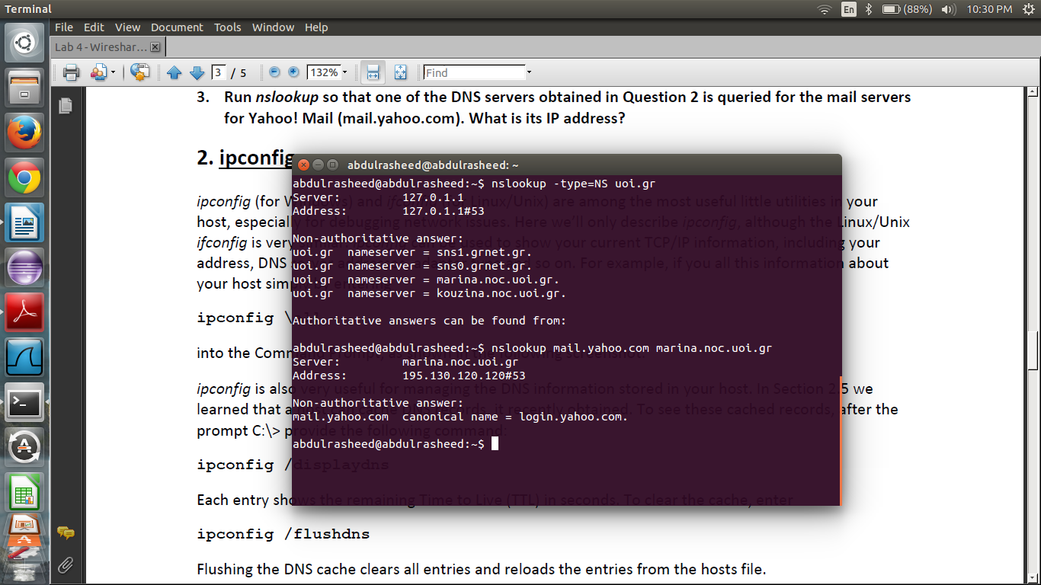Q#4

Packet no. : 769 & 770

Query and response message is sent over UDP because in packet detail window User Datagram Protocol appears.

Q#5

Local server is the destination of query with PORT: 53 while source PORT: 51436

Q#6

Destination IP = 192.168.1.1  
local DNS IP and destination IP are same because the query is sent to local DNS server

Q#7

Type : A and there are no Answers

Q#8

Answers = 3

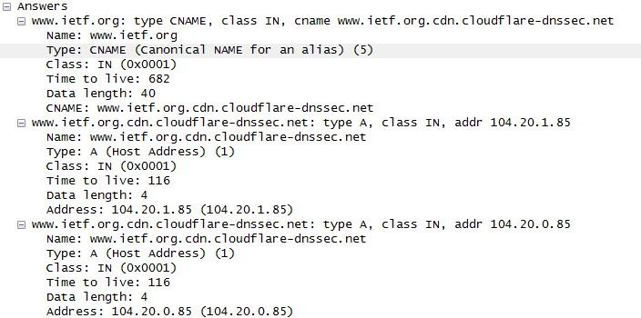

Q#9

No. the destination IP address of SYN packet doesn’t respond to any of IP addresses in response message. 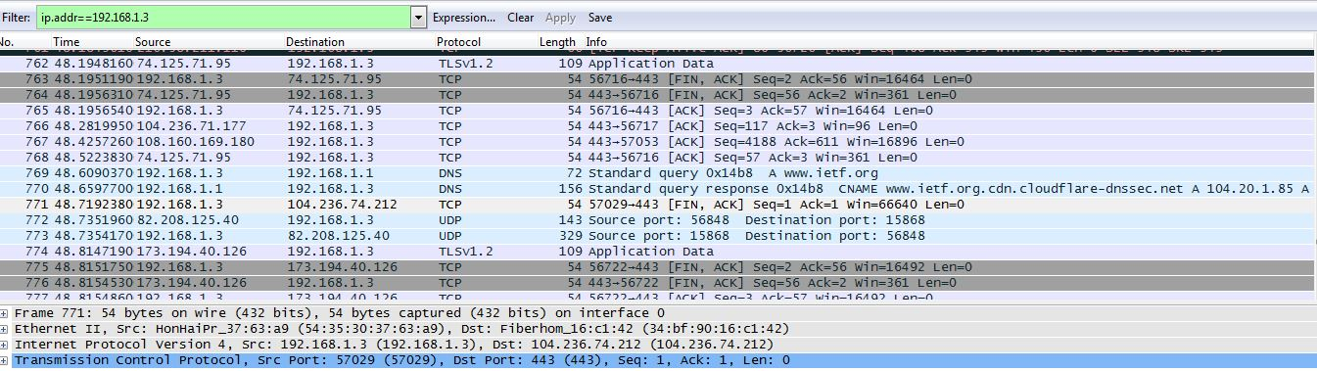

Q#10

Destination Port of Query: 53

Source Port of response: 53

Q#11

Destination: 192.168.1.1

Yes it is the IP address of default local DNS server.

Q#12

Answers: 0

Type: A

Q#13

Answers: 3

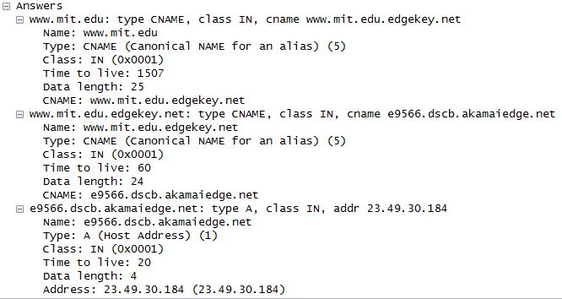

Q#15

Query message is sent to local DNS server with IP: 192.168.1.1

Q#16

TYPE: NS & Answers: 0

Q#17

MIT name servers are shown in figure below and they were not provided with their IP addresses.

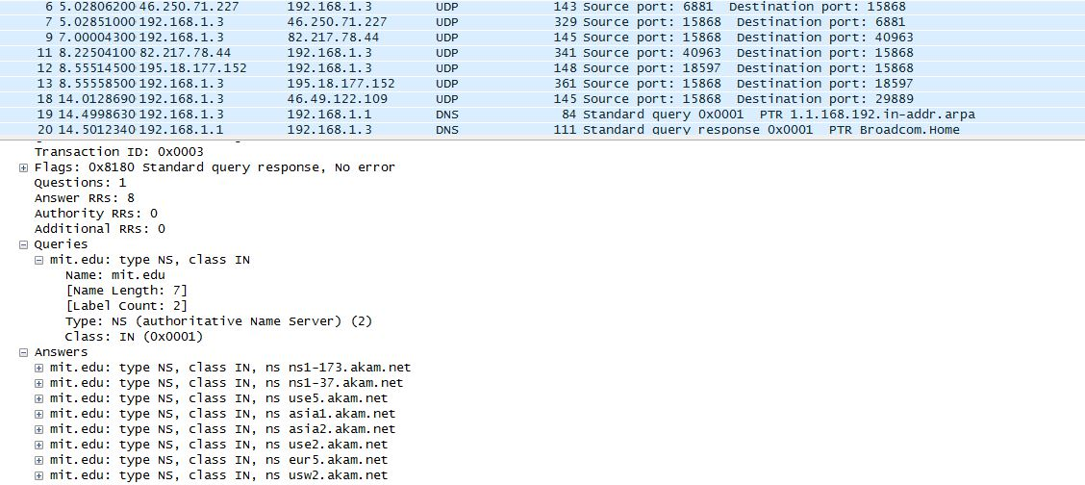

Q#19

Destination IP = 2.16.40.64

This IP address corresponds to use5.akam.net (one of the mit nameservers)

Q#20

Type : A

Answers: 0

Q#21

The response from [www.aiit.or.kr](http://www.aiit.or.kr) is “refused”.

It means server cannot find the query requested.

